3D Reconstruction

CMPT 412

Aditya Rajvanshi – 301349754

Part 3.1: Sparse Reconstruction

Part 3.1.1: Implement the Eight Point Algorithm

F = $\left[\begin{matrix}0.0000 & 0.0000 & -0.0000 \\ -0.0000 & -0.0000 & -0.0006 \\ 0.0000 & -0.0006 & -0.0027\end{matrix}\right]$

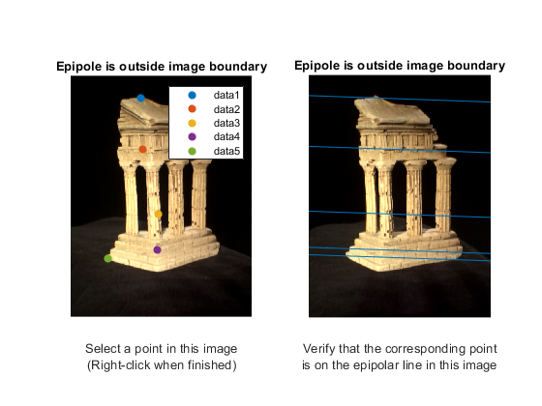

Part 3.1.2: Find Epipolar Correspondences

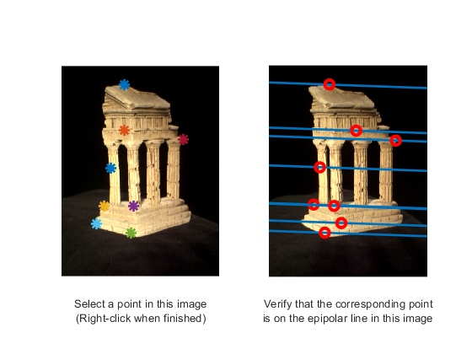

I used the Manhattan distance with window size 10, between a target window of image 1 and candidate window of image 3. Typically, the matching algorithm succeeded but it failed when there were too many similar but unmatched windows along the epipolar line.

Part 3.1.3: Compute the Essential Matrix

E = $\left[\begin{matrix}0.0075 & 0.0059 & -0.0300 \\ -0.2157 & -0.0300 & 0.8630 \\ 0.0082 & -0.8706 & 0.0010\end{matrix}\right]$

Part 3.1.4: Implement Triangulation

To find the correct extrinsic matrix, all 4 sets of 3D points must be computed with 4 candidate extrinsic matrices. After that, for each set, the number of positive depth coordinates are counted. Finally, the candidate with the highest count is the correct extrinsic matrix. The reprojection error for pts1 was 0.5827 and the error for pts2 was 0.5872.

Part 3.1.5: Write a Test Script That Uses templeCoords

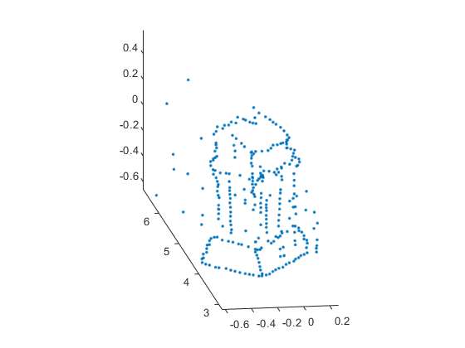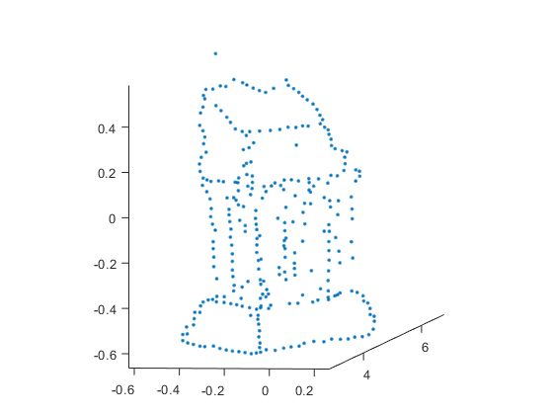

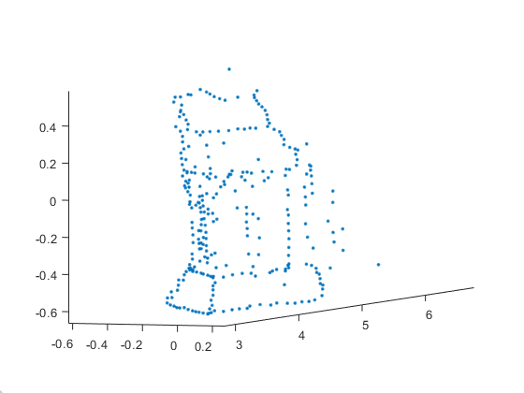

Part 3.2.1: Image Rectification

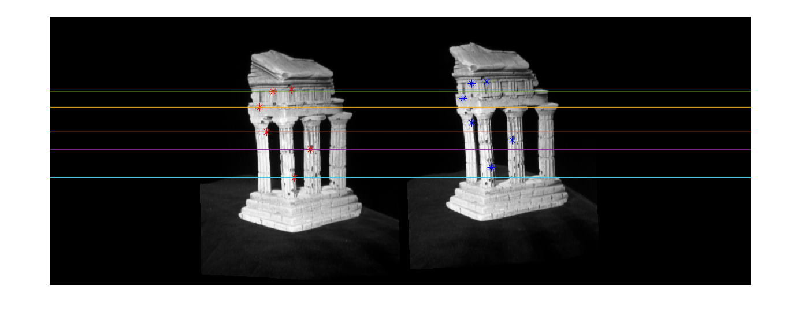

Part 3.2.2: Dense Window Matching to Find Per Pixel Density

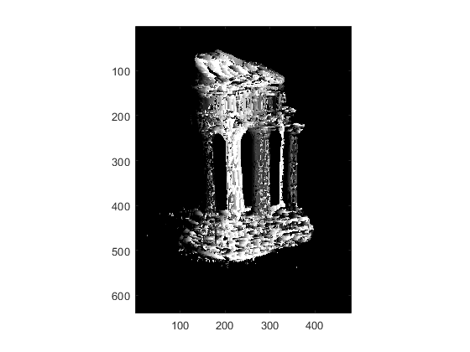

Part 3.2.3: Depth Map

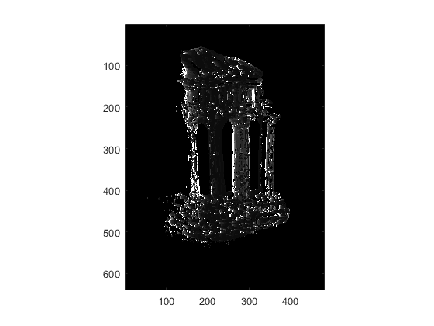

Part 3.3.1: Estimate Camera Matrix

Reprojected Error with clean 2D points is 0.0000

Pose Error with clean 2D points is 0.0000

------------------------------

Reprojected Error with noisy 2D points is 2.0577

Pose Error with noisy 2D points is 0.6941